**NOTE: This template is shareware downloaded from** [**www.processimpact.com**](http://www.processimpact.com)**. All shareware payments are donated to the Norm Kerth Benefit Fund to help a consultant who is disabled with a brain injury. Please visit** [**http://www.processimpact.com/norm_kerth.html**](http://www.processimpact.com/norm_kerth.html) **to make a shareware payment ($10 suggested). Thank you!**

Software Requirements Specification

for

Fitness Guidance Web Application

Version 1.0 approved

Prepared by

|  |  |  |
| --- | --- | --- |
| 75 | Prem Nagesh Mhetre | 22420297 |
| 74 | Omkar Dattatray Babar | 22420276 |
| 71 | Vedant Kishor Wahile | 22420176 |
| 72 | Tejas Ranjit Deore | 22420180 |

Vishwakarma Institute of Information Technology, Pune

01-August- 2025

eLearning versions of several popular Process Impact training seminars are available at [www.processimpact.com/elearning.shtml](http://www.processimpact.com/elearning.shtml), including “In Search of Excellent Requirements,” “Exploring User Requirements with Use Cases,” “Writing High-Quality Requirements,” “Software Inspections and Peer Reviews,” and “Project Management Best Practices”. Single-user and corporate-wide site licenses are both available.

Table of Contents

Table of Contents ii

Revision History ii

1. Introduction 1

1.1 Purpose 1

1.2 Document Conventions 1

1.3 Intended Audience and Reading Suggestions 1

1.4 Project Scope 1

1.5 References 1

2. Overall Description 2

2.1 Product Perspective 2

2.2 Product Features 2

2.3 User Classes and Characteristics 2

2.4 Operating Environment 2

2.5 Design and Implementation Constraints 2

2.6 User Documentation 3

2.7 Assumptions and Dependencies 3

3. System Features 3

3.1 System Feature 1 3

3.2 System Feature 2 (and so on) 3

4. External Interface Requirements 4

4.1 User Interfaces 4

4.2 Hardware Interfaces 4

4.3 Software Interfaces 4

4.4 Communications Interfaces 4

5. Other Nonfunctional Requirements 4

5.1 Performance Requirements 4

5.2 Safety Requirements 4

5.3 Security Requirements 4

5.4 Software Quality Attributes 4

6. Other Requirements 5

Appendix A: Glossary 5

Appendix B: Issues List 5

Appendix C: Analysis Models 6

Revision History

|  |  |  |  |
| --- | --- | --- | --- |
| **Name** | **Date** | **Reason For Changes** | **Version** |
| SRS Document | 25-07-2025 | Creating the SRS Document for the Hostel MS | *version-1.1* |
|  |  |  |  |

# Introduction

## Purpose

This document outlines the Software Requirements Specification (SRS) for Fitness Guider...

## Document Conventions

The system is developed using the following technology stack: React.js with Material UI, Node.js with Express, PostgreSQL.

## Intended Audience and Reading Suggestions

This document is intended for developers involved in the design and implementation of the system...

## Project Scope

Fitness Guider is a standalone web application intended to assist users in their fitness journey...

## References

• PostgreSQL Official Docs  
• React.js Docs  
• Material UI Docs  
• JWT Authentication

# Overall Description

## Product Perspective

Fitness Guider is a standalone solution...

## Product Features

• BMI Calculator  
• Personalized workout plans  
• Customized nutrition and diet plans  
• AI chatbot  
• JWT Authentication

## User Classes and Characteristics

General Users: Anyone interested in fitness.

## Operating Environment

* Browsers: Chrome, Firefox
* OS: Windows/Linux
* DB: PostgreSQL
* Server: Node.js with Express

## Design and Implementation Constraints

React + Material UI, Node.js + Express, PostgreSQL, JWT.

## User Documentation

* User manual
* Online help section
* Admin panel guide

## Assumptions and Dependencies

* Assumes availability of stable internet
* Assumes basic digital literacy of users
* Google Maps API (for location integration)

# System Features

**3.1 BMI Calculator**

Priority: High

Stimulus/Response: User inputs height and weight; system returns BMI category

Functional Requirements:  
- REQ-1: Accept inputs  
- REQ-2: Validate and calculate BMI  
- REQ-3: Display result

**3.2 Workout Plan Generator**

Priority: High

Stimulus/Response: User selects level; system provides workout split

Functional Requirements:  
- REQ-4: Fitness level options  
- REQ-5: Weekly plan display

**3.3 Nutrition Plan Generator**

Priority: High

Stimulus/Response: User selects diet preference; system generates plan

Functional Requirements:  
- REQ-6: Choose preference  
- REQ-7: Generate meal plan

**3.4 Chatbot**

Priority: Medium

Stimulus/Response: User types query; bot responds

Functional Requirements:  
- REQ-8: Respond to FAQs  
- REQ-9: Contact support option

**3.5 Authentication**

Priority: High

Functional Requirements:  
- REQ-10: JWT login/signup/logout  
- REQ-11: Token validation

# External Interface Requirements

## User Interfaces

Responsive UI using Material UI components.

## Hardware Interfaces

Not applicable.

## Software Interfaces

React frontend, Express backend, PostgreSQL database.

## Communications Interfaces

Uses HTTPS, JWT, and REST APIs.

# Nonfunctional Requirements

• Performance: Load within 2 seconds

• Safety: Includes disclaimers

• Security: JWT, HTTPS, input validation

• Quality: Usability, reliability, maintainability, portability

• Business Rules: Authenticated access

## 6. Other Requirements

• Store user preferences and history  
• Future: Mobile support, multilingual

## Appendix A: Glossary

**• BMI: Body Mass Index  
• JWT: JSON Web Token  
• API: Application Programming Interface**

## Appendix B: Issues List

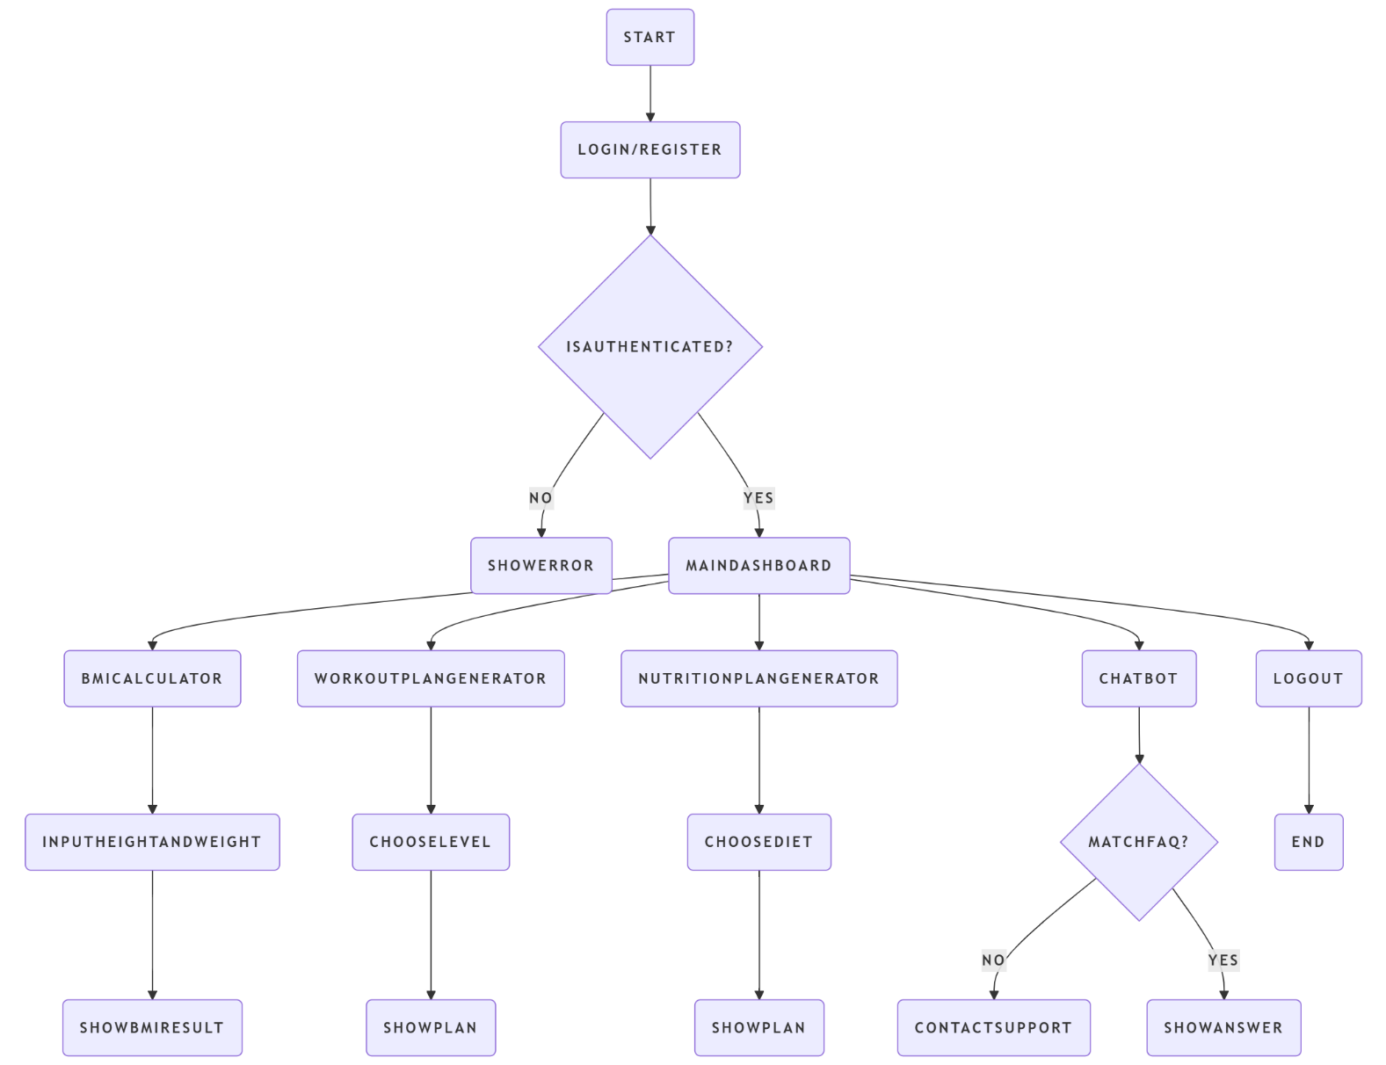

## Appendix C: Analysis Models

• TBD-1: Chatbot scope  
• TBD-2: Admin dashboard